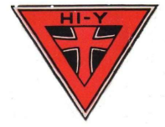
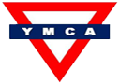
Hi-Y (High School unit -YMCA Nagercoil)
(A High School Student Programme of YMCA)

Membership Application Form

Name
Date of Birth
School Name
Class:
Mailing Address
(In Block Letters)
Phone/Mobile No.
Email ID
Father’s/Mother’s Name

Check Your Interests (Tick ✔ as applicable)
Debating | Music | Group Discussion | Dramatics | Sports | Literature | Science

Other Interests (Specify):

Fee Details
Enclosed Rs.100/- per annum towards Annual Membership.

Signatures
| Date: ___ / ___ / ______ | Signature of Applicant: ___________________________

Signature of the Parent:
For Office Use Only
Date of receipt of application
Amount paid
Meetings attended (with date)
Submission to Board (Date)
Board’s Recommendation & Decision
Application Accepted/Rejected
Communication Date to Applicant
Date of Induction
Any Other Remarks

Signature of Vice-President (Administration): ________________________________

